St Mark of Ephesus Greek Orthodox Cathedral
July 2020-Parish Nursing Ministry
"It is impossible,someone says, impossible to spend the present day devoutly unless we regard it as the last day of our whole life"
-St. John Climacus

I Pray all are enjoying our summer, it's been beautiful but a very unique time in our country's history. It continues to be important to take steps to protect ourselves and others from Covid19. As has been seen in the south, southwest , and west, it is still a virilant virus so to continue to practice good hygiene. washing hands, practicing social distancing, wearing face coverings are still considered good preventive measures. I know we've all had opportunities to get out and about maybe going on hikes or to the beach and I wanted to share information on various bug bites that could be injurious to our health. Ticks and mosquitos are becoming more active and can carry various diseases. It's advised to stay healthy before stepping outside use insect repellant, and were possible wear long-sleeved sleeves, and long pants outdoors to prevent insect bites. and stay away from tall plants and grasses. Once you're back inside be sure to check youself for ticks or mosquito bites. If you have a tick-borne disease or mosquito-borne illness call your doctor as soon as possible.

It's also good to have a home first-aid kit
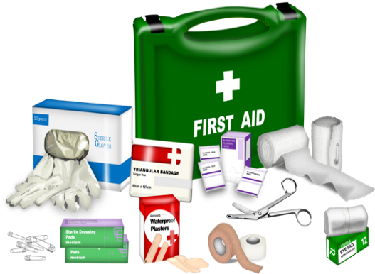
The Red Cross recommends;

1. Absorbent compress dressing, to help stop severe bleeding.
2. Adhesive cloth tape- to hold compress dressings in place,
3. Adhesive bandages, of assorted sizes
4. Antibiotic ointment- such as bacitracin, polysporin or mupirocin
5. Antiseptic solution or wipes- such as hydrogen peroxide, povidone-iodine or chlorhexidine
6. Aspirin- in the event of a heart attack
7. Instant cold compress
8. Nonlatex gloves
9. Hydrocortisone ointment
10. Three-and 4 inch gauze roll bandages
11. Box of sterile gauze pads for sterile wound dressings
12. Triangular bandage to use as a bandage or tourniquet
13. Oral thermometer
14. Tweezers
15. CPR mask to be used when administering CPR
Some other items are petroleum jelly, pain relievers, antihistamines

Another important issue is to have a list of whatever medications you are taking in a prominent place so if you are in an emergency you or a family member would be able to share this important information.

Well Truly, Glory be to God for all Things as we travel this rocky road of life pray you are well. If you do have any questions or concerns about your health please contact your health care provider.

In Christ,
Elizabeth Ashton RN

