+
St Mark of Ephesus Orthodox Cathedral
Parish Nurse Ministry-April 2020

"Angels are a light for monks and monastic life is a light for all men. Hence monks should spare no effort to become a shining example in all things and they should give no scandal to anything they say or do. For if the light becomes dark, then all the deeper will be the darkness of those living in the world."
-St. John Climacus

Recently Metropolitan Demetrios shared missives to the faithful on our current state of challenges and affairs stating that the church is our hospital. We pray our ever-merciful Lord continues to give strength to our spiritual leaders to guide us through these perilous and dark times. We have the blessing of these earthly lights, but our Lord's Resurrection shines on us the Light of Eternity.

We are going through physical, emotional and spiritual experiences many of us have never had to live through before. And thank our ever-merciful Lord we have our Orthodoxy and the church as our succor and aid and our Lord's glorious Resurrection to guide us during difficult times and we should never forget we are truly our brothers keepers so if there are those in need or distress please give a call or send a card to let them know they are being thought of.

Of course, we are now in uncharted territory with the COVID-19 so please keep hygienic lifestyles by washing hands frequently and keeping safe distances from one another as this is a very infectious virus.

These are a few suggestions to keep our health strong as we experience our current state of affairs from a recent article in Consumer Reports on Health; research found that we need at least 7-8 hours of sleep (although as we age our sleep-wake patterns may change).

We should be exercising at least 150 minutes a week this includes aerobic activity such as brisk walking and muscle strengthening as well as balance training.

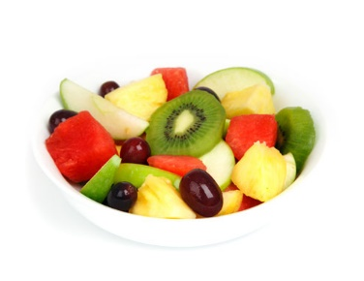
Dietary guidelines suggest women should have at least 1800 calories a day and men 2000 calories a day. Having between 5-10 servings of fruit and vegetables a day has been shown to reduce the risk of stroke and heart attacks.

We should also reduce our alcohol intake to 1-2 glasses a day A Lancet study found that just one drink per day raised the risk of diseases such as cancer and heart diesease.

These are guidelines and suggestions from relevant research encouraging us to maintain healthy lifestyles. Of course, the Church helps us with this by providing us with wine & oil days and teaching that moderation is best.

***Do you have an encouraging word to give here to us as we are called upon to pray our homes, deal with extra stress and perhaps be a bit more couped up with each other??? ***

As always if you experience any changes in your health and well-being please call and or see your health care provider.

Love in Christ,
Elizabeth Ashton RN

